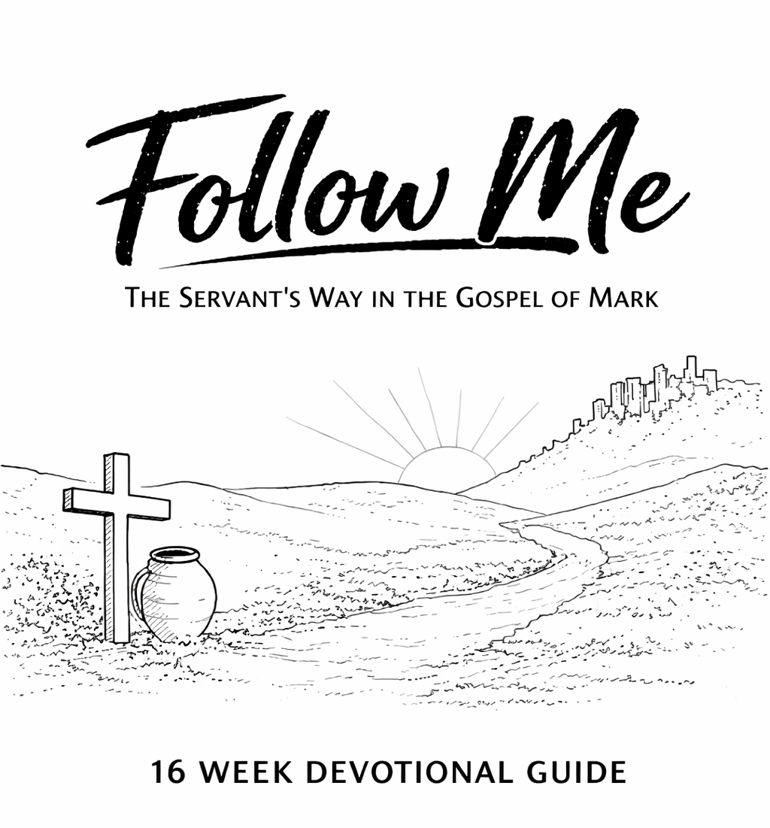

Created by Pastor Leo Vollbracht for Lakewood Park Church

How to Use This Devotional
This guide is designed to help you intentionally grow as a disciple of Jesus over the next sixteen weeks. Each week corresponds with our Sunday sermon and focuses on one chapter of the book of Mark. The idea is to get started and stay consistent.

Each week includes:
Six daily key Scripture (Use the 7th day for reflection and sabbath)
A daily devotional statement
Space to practice SOAP Bible study

How to Practice SOAP
SOAP is a simple and powerful way to engage Scripture personally.
S — Scripture
Write out the key verse or passage that stands out to you.
O — Observation
What do you notice? What is happening in the text? What does this reveal about God, people, or yourself?
A — Application
How is God asking you to respond? What needs to change, begin, or deepen in your life?
P — Prayer
Write a personal prayer based on what God has shown you.
Take your time. Write honestly. The goal is not perfection but transformation.

WEEK 1 – MARK 1: CALLED TO FOLLOW
Day 1 – Mark 1:1–8
Devotional: God prepares the way before He calls us forward.
SOAP:
S:
O:
A:
P:

Day 2 – Mark 1:9–13
Devotional: Even Jesus faced testing—following Him includes challenge.
SOAP:
S:
O:
A:
P:

Day 3 – Mark 1:14–20
Devotional: Jesus calls for a step, not full understanding.
SOAP:
S:
O:
A:
P:

Day 4 – Mark 1:21–34
Devotional: Jesus uses His authority to serve others.
SOAP:
S:
O:
A:
P:

Day 5 – Mark 1:35–39
Devotional: Time with God fuels service for others.
SOAP:
S:
O:
A:
P:

Day 6 – Mark 1:40–45
Devotional: A servant’s heart moves toward the overlooked.
SOAP:
S:
O:
A:
P:

WEEK 2 – MARK 2: PEOPLE OVER PLATFORM
Day 1 – Mark 2:1–12
Devotional: Faith often brings others to Jesus.
SOAP:
S:
O:
A:
P:

Day 2 – Mark 2:13-17
Devotional: Jesus calls unlikely people.
SOAP:
S:
O:
A:
P:

Day 3 – Mark 2:18-22
Devotional: Jesus brings something new.
SOAP:
S:
O:
A:
P:

Day 4 – Mark 2:23-28
Devotional: People matter more than rules.
SOAP:
S:
O:
A:
P:

Day 5 – Reread the whole chapter
Devotional: Where is Jesus reshaping your priorities?
SOAP:
S:
O:
A:
P:

Day 6 – Reread the entire chapter
Devotional: What one verse sticks out the most to you?
SOAP:
S:
O:
A:
P:

WEEK 3 – MARK 3: BE WITH HIM
Day 1 – Mark 3:1–6
Devotional: Compassion over criticism.
SOAP:
S:
O:
A:
P:

Day 2 – Mark 3:7–12
Devotional: Jesus serves crowds without losing focus.
SOAP:
S:
O:
A:
P:

Day 3 – Mark 3:13–19
Devotional: Called first to be with Him.
SOAP:
S:
O:
A:
P:

Day 4 – Mark 3:20–30
Devotional: Following Jesus brings opposition.
SOAP:
S:
O:
A:
P:

Day 5 – Mark 3:30–35
Devotional: Take Jesus seriously.
SOAP:
S:
O:
A:
P:

Day 6 – reread the chapter
Devotional: What verse sticks out the most? What will you do about it?
SOAP:
S:
O:
A:
P:

WEEK 4 – MARK 4: FAITHFUL IN SMALL THINGS
Day 1 – Mark 4:1–9
Devotional: How is your heart receiving God’s Word?
SOAP:
S:
O:
A:
P:

Day 2 – Mark 4:10–20
Devotional: Growth depends on the condition of your heart.
SOAP:
S:
O:
A:
P:

Day 3 – Mark 4:21–25
Devotional: What God does in you is meant to shine.
SOAP:
S:
O:
A:
P:

Day 4 – Mark 4:26–29
Devotional: Growth happens slowly and steadily.
SOAP:
S:
O:
A:
P:

Day 5 – Mark 4:30–34
Devotional: Small beginnings matter.
SOAP:
S:
O:
A:
P:

Day 6 – Mark 4:35–41
Devotional: Trust Jesus even in uncertainty.
SOAP:
S:
O:
A:
P:

WEEK 5 – MARK 5: FOR THE ONE
Day 1 – 5:1–20
Devotional: No one is beyond Jesus’ reach.
SOAP:
S:
O:
A:
P:

Day 2 – 5:1–20 (again)
Devotional: Your story matters.
SOAP:
S:
O:
A:
P:

Day 3 – 5:21–24
Devotional: Bring your needs to Jesus.
SOAP:
S:
O:
A:
P:

Day 4 – 5:25–34
Devotional: Faith reaches out.
SOAP:
S:
O:
A:
P:

Day 5 – 5:35–43
Devotional: Jesus brings hope beyond fear.
SOAP:
S:
O:
A:
P:

Day 6 – Reread the entire chapter
Devotional: Where do you need healing? Ask Jesus for that healing. Write a verse from the chapter that gives you strength.

SOAP:
S:
O:
A:
P:

WEEK 6 – MARK 6: WHEN IT’S HARD
Day 1 – 6:1-6a
Devotional: Familiarity can limit faith.
SOAP:
S:
O:
A:
P:

Day 2 – 6:6b–13
Devotional: Jesus sends ordinary people.
SOAP:
S:
O:
A:
P:

Day 3 – 6:14–29
Devotional: Following Jesus can be costly.
SOAP:
S:
O:
A:
P:

Day 4 – 6:30–44
Devotional: Jesus has compassion on the weary.
SOAP:
S:
O:
A:
P:

Day 5 – 6:30–44 (again)
Devotional: Jesus models and asks us to offer what you have.
SOAP:
S:
O:
A:
P:

Day 6 – 6:45–56
Devotional: Jesus meets us in the struggle.
SOAP:
S:
O:
A:
P:

WEEK 7 – MARK 7: FROM THE INSIDE OUT
Day 1 – 7:1–8
Devotional: Jesus is looking for transformation NOT tradition.
SOAP:
S:
O:
A:
P:

Day 2 – 7:9–13
Devotional: We are called to honor God genuinely, not just by making and keeping rules but by living through grace and love.
SOAP:
S:
O:
A:
P:

Day 3 – 7:14–23
Devotional: Jesus calls us and gives us grace to change from the inside out.
SOAP:
S:
O:
A:
P:

Day 4 – 7:24–30
Devotional: Jesus honors our faith.
SOAP:
S:
O:
A:
P:

Day 5 – 7:31–37
Devotional: Jesus has the power to restore what is not present.
SOAP:
S:
O:
A:
P:

Day 6 – Reread the entire chapter
Devotional: How do you honor God in with your faith?

SOAP:
S:
O:
A:
P:

WEEK 8 – MARK 8: LEARNING TO SEE
Day 1 – 8:1–10
Devotional: Jesus provides in compassion for others.
SOAP:
S:
O:
A:
P:

Day 2 – 8:11–13
Devotional: Jesus can help our unbelief but the commandment says do not test the Lord your God.
SOAP:
S:
O:
A:
P:

Day 3 – 8:14–21
Devotional: Jesus calls us to look past the natural and see/hear the super natural. Discernment is important.
SOAP:
S:
O:
A:
P:

Day 4 – 8:22–26
Devotional: Growth takes time.
SOAP:
S:
O:
A:
P:

Day 5 – 8:27–30
Devotional: Who is Jesus to you?
SOAP:
S:
O:
A:
P:

Day 6 – 8:31–38
Devotional: Following Jesus requires surrender and true faith.
SOAP:
S:
O:
A:
P:

WEEK 9 – MARK 9: REDEFINING GREATNESS
Day 1 – 9:1–8
Devotional: Jesus is who he says he is, only God glows in pure light!
SOAP:
S:
O:
A:
P:

Day 2 – 9:9–13
Devotional: Sometimes we need to give God time to make things clear, pray, don’t rush!
SOAP:
S:
O:
A:
P:

Day 3 – 9:14–29
Devotional: Bring your doubts to Jesus for wisdom.
SOAP:
S:
O:
A:
P:

Day 4 – 9:30–32
Devotional: Jesus prepares His followers, surrender to him.
SOAP:
S:
O:
A:
P:

Day 5 – 9:33–37
Devotional: Jesus modeled what the greatest in the kingdom looks like, they look like servants.
SOAP:
S:
O:
A:
P:

Day 6 – 9:38–50
Devotional: Jesus calls us to take the mission to make disciples seriously, especially toward the least.
SOAP:
S:
O:
A:
P:

WEEK 10 – MARK 10: THE SERVANT KING
Day 1 – 10:1–12
Devotional: Faithfulness matters to Jesus, he modeled love that is sacrificial, covenantal, and forever.
SOAP:
S:
O:
A:
P:

Day 2 – 10:13–16
Devotional: We are called to childlike faith. How are you doing with that?
SOAP:
S:
O:
A:
P:

Day 3 – 10:17–22
Devotional: What are you holding onto that God is calling you to surrender? How is it standing in the way of your growth?
SOAP:
S:
O:
A:
P:

Day 4 – 10:23–31
Devotional: Trust God fully and surrender to the call.

SOAP:
S:
O:
A:
P:

Day 5 – 10:32–45
Devotional: Serve like Jesus who served sacrificially, compassionately, and other-focused.
SOAP:
S:
O:
A:
P:

Day 6 – 10:46–52
Devotional: Jesus knows what you need but still likes that you ask. Ask him in prayer for everything and in nothing be anxious.
SOAP:
S:
O:
A:
P:

WEEK 11 – MARK 11: HUMBLE KING
Day 1 – 11:1–11
Devotional: Jesus’s humble entrance was that of a king, prophet and priest.
SOAP:
S:
O:
A:
P:

Day 2 – 11:12–18
Devotional: The fruit of our lives matters. What fruit have you produced lately? Who are you telling about Jesus?
SOAP:
S:
O:
A:
P:

Day 3 – 11:19–26
Devotional: How is your faith? Where can you grow in faith?
SOAP:
S:
O:
A:
P:

Day 4 – 11:27–33
Devotional: The authority of Jesus is clearly from God. Do you ever question that authority?
SOAP:
S:
O:
A:
P:

Day 5 – Reread your favorite day
Devotional: Why does this part of scripture stand out to you?
SOAP:
S:
O:
A:
P:

Day 6 – Reread the entire chapter.
Devotional: What is your key take away for this week?

SOAP:
S:
O:
A:
P:

WEEK 12 – MARK 12: LOVE FIRST
Day 1 – 12:1–12
Devotional: We are but care takers of the kingdom, it is God who created and owns it all.
SOAP:
S:
O:
A:
P:

Day 2 – 12:13–17
Devotional: Give God what is His.
SOAP:
S:
O:
A:
P:

Day 3 – 12:18–27
Devotional: How well do you know the scripture?
SOAP:
S:
O:
A:
P:

Day 4 – 12:28–34
Devotional: Jesus loved God and people, we should do the same thing.
SOAP:
S:
O:
A:
P:

Day 5 – 12:35–40
Devotional: Jesus reminds us of who he is but also warns against pride. Jesus has reason to be full of pride yet lays aside his greatness and exemplifies humility instead. How about you?
SOAP:
S:
O:
A:
P:

Day 6 – 12:41–44
Devotional: The word calls us to give wholeheartedly and out of our resources. Do you give comfortably or sacrificially?
SOAP:
S:
O:
A:
P:

WEEK 13 – MARK 13: STAY READY
Day 1 – 13:1–8
Devotional: Jesus calls us to stay alert.
SOAP:
S:
O:
A:
P:

Day 2 – 13:9–13
Devotional: Jesus calls us to stand firm.
SOAP:
S:
O:
A:
P:

Day 3 – 13:14–23
Devotional: Trust God in chaos.
SOAP:
S:
O:
A:
P:

Day 4 – 13:24–37
Devotional: Jesus will return and we need to watch for signs. But where can this go wrong? How can pride and religious zealousness sneak in as we look for signs?
SOAP:
S:
O:
A:
P:

Day 5 – Reread your favorite part of the chapter.
Devotional: Why is this so important for your life today?
SOAP:
S:
O:
A:
P:

Day 6 – Reread the whole chapter.
Devotional: What sticks out as a next step?
SOAP:
S:
O:
A:
P:

WEEK 14 – MARK 14: WHEN NO ONE SEES
Day 1 – 14:1–11
Devotional: We should give and worship sacrificially.
SOAP:
S:
O:
A:
P:

Day 2 – 14:12–26
Devotional: Guard your heart and remember Jesus.
SOAP:
S:
O:
A:
P:

Day 3 – 14:27-31
Devotional: Has Jesus ever surprised you with a thought or inkling before it happen and when it did you remembered his words/warning?
SOAP:
S:
O:
A:
P:

Day 4 – 14:32–42
Devotional: Pray in the struggle and pray through even if you don’t have the strength.
SOAP:
S:
O:
A:
P:

Day 5 – 14:43–52
Devotional: At what points are you like the disciples and have deserted Jesus?
SOAP:
S:
O:
A:
P:

Day 6 – 14:53–72
Devotional: Failure isn’t final, there is always redemption.
SOAP:
S:
O:
A:
P:

WEEK 15 – MARK 15: THE CROSS
Day 1 – 15:1–15
Devotional: Jesus stands silent and allows the world to make of him what they will.
SOAP:
S:
O:
A:
P:

Day 2 – 15:16–20
Devotional: Jesus endured suffering.
SOAP:
S:
O:
A:
P:

Day 3 – 15:21–32
Devotional: The weight of the cross
SOAP:
S:
O:
A:
P:

Day 4 – 15:33–39
Devotional: It is finished, Jesus has paid it all.
SOAP:
S:
O:
A:
P:

Day 5 – 15:40–47
Devotional: Faithfulness in grief
SOAP:
S:
O:
A:
P:

Day 6 – Reread the entire chapter
Devotional: How does the cross point us toward service?

SOAP:
S:
O:
A:
P:

WEEK 16 – MARK 16: GO
Day 1 – 16:1–8
Devotional: The resurrection changes everything
SOAP:
S:
O:
A:
P:

(Some bibles won’t have the following verses… It’s OK. If yours doesn’t just read a different version, the NIV has them as a foot note, reread another chapter, or reread the good news of the resurrection each day this week.)
Day 2 – 16:9–11
Devotional: Share the good news
SOAP:
S:
O:
A:
P:

Day 3 – 16:12–14
Devotional: Jesus meets doubt
SOAP:
S:
O:
A:
P:

Day 4 – 16:15–18
Devotional: Go into all the world
SOAP:
S:
O:
A:
P:

Day 5 – 16:19–20
Devotional: Jesus is still at work
SOAP:
S:
O:
A:
P:

Day 6 – Read the chapter again.
Devotional: How will you live out the Goodnews?
SOAP:
S:
O:
A:
P:

FINAL ENCOURAGEMENT
You’ve come a long way.
Not just through pages…
Not just through chapters…
But through a journey of learning what it truly means to follow Jesus.
Along the way, you’ve seen Him—
teaching, healing, serving, suffering, giving everything.
And maybe you’ve seen yourself too—
in moments of faith…
and moments of doubt…
in bold steps forward…
and quiet resistance.
That’s part of the journey.
Because following Jesus was never meant to be perfect—
it was meant to be daily.
Jesus didn’t call perfect people.
He called willing people.
He didn’t say, “Figure it all out.”
He said, “Follow me.”
And now the question is not, “Did you finish the devotional?” The real question is, “Will you keep following?”
Following Jesus means:
- Choosing humility when pride feels easier
- Serving when no one notices
- Loving when it costs something
- Trusting when life feels uncertain
- Showing up again… and again… and again

You don’t have to have it all together. You just have to keep taking the next step.
Because discipleship isn’t a destination you arrive at…it’s a path you walk.
So as this guide comes to an end, your journey does not.

This is where it continues:
In your home
In your work
In your relationships
In your church
In the quiet places no one else sees
The same Jesus who said “Follow me”, is still walking ahead of you.
Still leading.
Still calling.
Still inviting you into a life that looks like His.
So keep going.
Keep growing.
Keep serving.
Keep becoming more like Him.

